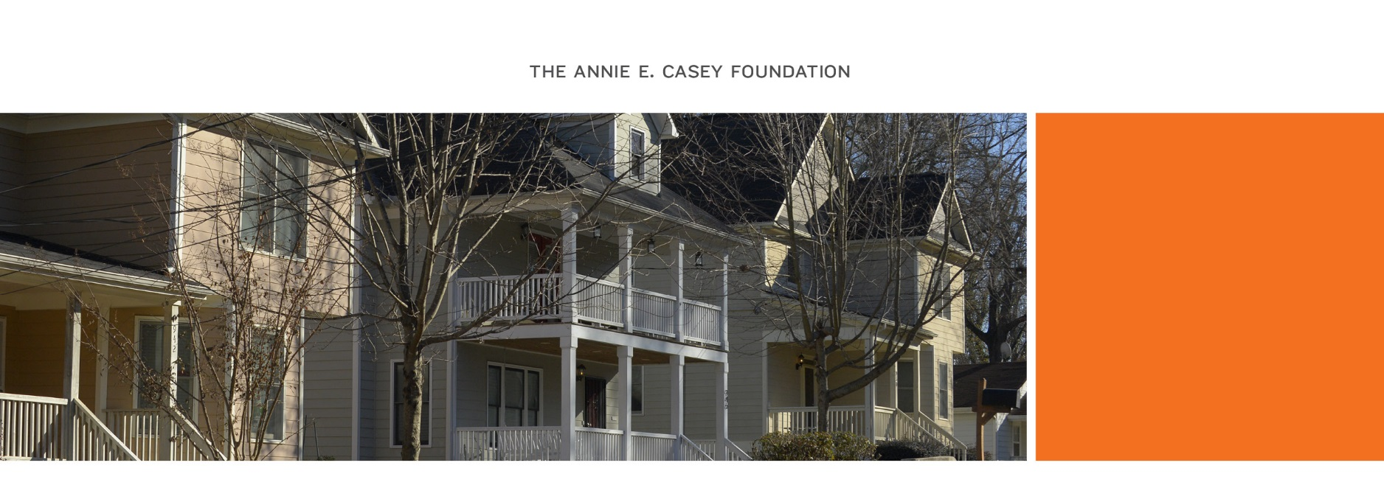
Resident Leaders for Equity

NPU-V Neighbors: adin

We invite you and other residents across the NPU-V neighborhoods (Peoplestown, Mechanicsville, Summerhill, Adair Park, Pittsburgh and Capitol Gateway) to apply to be a part of the Resident Leaders for Equity Program. This long-term leadership development program for ten to fifteen NPU-V residents was created to strengthen community knowledge of racial equity skills and strategies, and create positive neighborhood change with support from the Annie E. Casey Foundation and the Partnership for Southern Equity.

As highlighted in the Changing the Odds report, Atlanta has deep and enduring racial disparities that make it one of the most difficult places in the nation for children of color from low-income families to succeed. The economy and demographics in the city are changing, impacting neighborhoods in NPU-V. In order to navigate these changes and ensure that all residents and their families have a chance to succeed, extensive leadership is needed at the neighborhood level. This program will support the growth of a diverse group of neighborhood leaders who will advocate for and help manage these processes and, in particular, the racial impacts of gentrification.

We hope a diverse pool of NPU-V residents — whether you are young or elderly, new to the area or a long-time resident, a renter or a homeowner, a parent or non-parent — will apply, as diversity is critical to sustaining an inclusive community. Selected residents must commit to approximately 8 sessions (over a 8-month period), to learn about racial equity, NPU-V history, displacement and community policies. There will also be additional optional sessions to support understanding and application of these concepts.

Program Specifics:
- Participants: 10-15 diverse NPU-V residents
- Time Commitment: 8 months
  - 1 meeting/month: (6)- six hour sessions, (1)-four hour session and graduation will be a two hour program (approximately 8 sessions total)
- Core curriculum: racial equity, community engagement and leadership development
- Participants will also work on community projects with the broader community.

Resident Leaders for Equity will:

- Understand racial equity and know how to communicate it effectively to different audiences.
- Practice communication tools important for influencing community stakeholders and authorities.
- Strengthen their ability to collaborate with new partners to address community issues, particularly issues related to racial equity and gentrification.
- Develop a strong understanding about the effects of racism on Atlanta’s neighborhoods.
- Increase their knowledge of the political landscape as it impacts their neighborhoods.
- Become equipped to take on greater leadership roles and expand their impact as leaders.
- Enhance skills in organizing and mobilizing community residents.
- Build trusted relationships with a peer group of local community leaders and advocates.
- Explore practices for managing neighborhood change, including policies both from Atlanta and other locations.

Upon completion of the program, leaders will be prepared to have effective conversations about race, analyze policies that impact their communities (specifically gentrification, neighborhood change and displacement) and facilitate and mediate difficult and complex conversations with their neighbors. Additionally, by the end of the course the Resident Leaders for Equity will have developed a group identity and group project that will address critical community .

Application schedule:

Date | Action Item
Sunday, April 7th, 5:00 p.m. | Application Deadline (see submission instructions below)
Monday , April. 8th | Application Review by Staff
Monday, April 8th –  Wednesday, April 10st | Candidate Interviews by Staff via conference call (Note: All applicants will not be interviewed, but staff reserve the right to interview or send questions to applicants and their references to clarify information submitted through the application or to narrow the pool of applicants; especially in situations where there is overrepresentation from certain groups.)
Monday, April 15rd | Selected Fellows Announced and All Applicants Notified.
Saturday, May 4rd | Program Start Date

Program Schedule:
Meeting Location: To Be Determined in NPU-V. Participants will be notified of the location on or before April 15th.

Module | Date | Program Duration | Proposed Program Meeting Time
1 | May 4th | 6 hours | 10am-4pm
2 | June 1st | 6 hours | 10am-4pm
3 | June 22nd | 6 hours | 10am-4pm
4 | July 27th | 6 hours | 10am-4pm
5 | Aug 31st | 6 hours | 10am-4pm
6 | Sept 28th | 6 hours | 10am-4pm
7 | Oct 19th | 4 hours | 10am-2pm
8 | Dec 7th | 2 hours | 12noon-2pm

Application (may be handwritten clearly or typed):

Title: | Full name:
Cell Phone: |  | Email:
Address:
City |  | Zip Code:
Neighborhood of residence:

The following information will help ensure that the Resident Leaders for Equity Cohort adequately reflects the diversity of the NPU-V communities. You are not required to answer, but your response will help us ensure an inclusive group.

Gender: □Female □Male | Age: □ 16–18 □ 19–24 □ 25–34 □ 35–54 □ 55+
Length of residence in NPU-V:
Race/ethnicity:
Do you have school-aged children? □Yes □No

If yes, do your children attend school in NPU-V? □Yes □No

If yes, are you involved in any parent groups? □Yes □No
If yes, please name the group(s):

______________________________________________________________________

1. Describe your current understanding of neighborhood change in the NPU-V communities, including impacts on housing, and how you think residents might help to address these issues.

2. How important is a discussion about race in Atlanta to you, and why?

3. Please discuss your ability to commit to Resident Leaders for Equity and what might hinder your commitment to attend the sessions.

4. When did you become engaged in your community? How have you been engaged? If you have not formally engaged in your community, how would you like to engage? What has prevented your engagement in the past and how can this program support your interests?

5. Describe your special skills and talents that you intend to contribute to the program.

Provide contact information for two references that could speak to your neighborhood leadership potential (references can be personal or professional):

Reference Name | Phone | Email Address | Relationship
You may also submit a résumé or additional information that you feel is important to note when considering your application. Please limit your attachments to no more than three pages.

Acknowledgment

Resident Leaders for Equity is a volunteer leadership development opportunity provided by the Annie E. Casey Foundation’s Atlanta Civic Site and the Partnership for Southern Equity. It is also a competitive program. This means that if you are accepted, it is expected that you will commit to fully taking advantage of the opportunity that has been entrusted to you and will be accountable to your peers in the group for your participation. You will be expected to attend all required training sessions and activities, with only two excused absences allowed. The group will discuss any obstacles that individuals may have to participation, such as child care or transportation, and consider whether it is possible to address those. You will be provided with training and leadership development, networking opportunities and an opportunity to positively impact your community.

Submission instructions:

Applications can be received in one of the following ways: 1) in person, 2) by mail, or 3) electronically by email (see below). These must be received by 5 pm on Sunday April 7th, 2019. Late applications will not be accepted.

In person or U.S. mail:

The Annie E. Casey Foundation
Attn: Resident Leaders for Equity
477 Windsor St., SW, Suite 304
Atlanta, GA 30312

Electronic Submittal: Application packets must be emailed to Ade Oguntoye at aoguntoye@aecf.org with the subject line of Resident Leaders for Equity.
Questions? Please contact Ade Oguntoye at aoguntoye@aecf.org or 678.686.0146.

